

PAD Scale — Pleasure

This image makes me feel pleasant.

1 = Not pleasant at all

2 = Slightly unpleasant

3 = Neutral

4 = Slightly pleasant

5 = Very pleasant

This image makes me feel comfortable.

1 = Not comfortable at all

2 = Slightly uncomfortable

3 = Neutral

4 = Slightly comfortable

5 = Very comfortable

Viewing this image makes me feel delighted.

1 = Not delighted at all

2 = Slightly delighted

3 = Neutral

4 = Somewhat delighted

5 = Very delighted

This image makes me feel happy.

1 = Not happy at all

2 = Slightly unhappy

3 = Neutral

4 = Somewhat happy

5 = Very happy

PAD Scale — Arousal

This image makes me feel excited.

1 = Not excited at all

2 = Slightly unexcited

3 = Neutral

4 = Somewhat excited

5 = Very excited

This image evokes a strong emotional response in me.

1 = No emotional response at all

2 = Very little emotional response

3 = Moderate emotional response

4 = Some emotional response

5 = A very strong emotional response

Viewing this image makes me feel highly interested.

1 = Not interested at all

2 = Not interested

3 = Neutral

4 = Somewhat interested

5 = Very interested

This image arouses strong curiosity in me.

1 = No curiosity at all

2 = Not very curious

3 = Neutral

4 = Somewhat curious

5 = Very curious

PAD Scale — Dominance

This image makes me feel that I can control my emotional response. (i.e., while viewing the image, I feel my emotions are under my control—for example, “I can decide whether or not to be moved by this image.”)

1 = Not controllable at all

2 = Slightly controllable

3 = Neutral

4 = Controllable

5 = Completely controllable

While viewing this image, I feel that I am not controlled by it. (i.e., how strongly the image influences my emotions. If I feel it has a strong influence on me, I am “controlled”; if it has little influence, I am “not controlled.”)

1 = Completely controlled

2 = Controlled

3 = Neutral

4 = Somewhat not controlled

5 = Completely not controlled

This image gives me a feeling of being dominated by emotion. (i.e., while viewing the image, my emotions feel “driven” by it—for example, suddenly feeling very depressed, excited, or carried along by the scene.)

1 = No such feeling at all

2 = Slightly such a feeling

3 = Neutral

4 = Somewhat dominated

5 = Completely dominated

While viewing this image, I feel that my emotions are guided by it. (i.e., whether the image “pulls” me toward a certain emotional direction, such as gradually making me feel relaxed, tense, curious, or uncomfortable.)

1 = No such feeling at all

2 = Slightly such a feeling

3 = Neutral

4 = Somewhat guided

5 = Completely guided

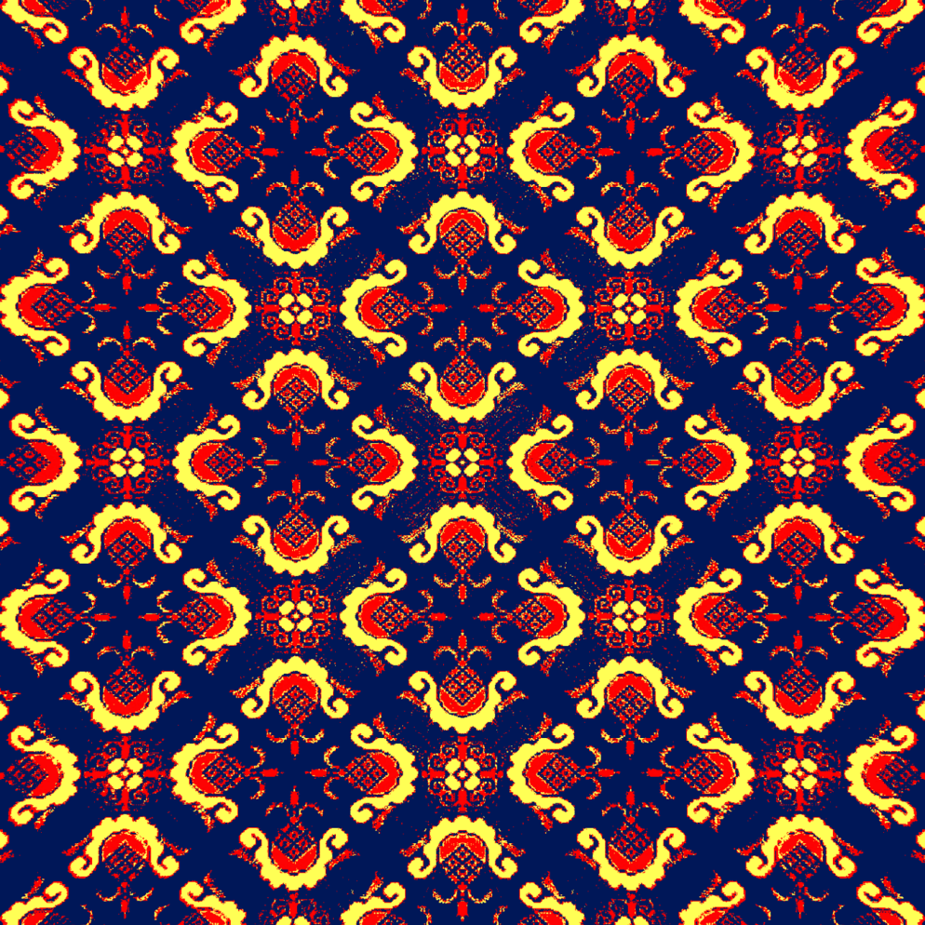

PAD Scale — Pleasure

This image makes me feel pleasant.

1 = Not pleasant at all

2 = Slightly unpleasant

3 = Neutral

4 = Slightly pleasant

5 = Very pleasant

This image makes me feel comfortable.

1 = Not comfortable at all

2 = Slightly uncomfortable

3 = Neutral

4 = Slightly comfortable

5 = Very comfortable

Viewing this image makes me feel delighted.

1 = Not delighted at all

2 = Slightly delighted

3 = Neutral

4 = Somewhat delighted

5 = Very delighted

This image makes me feel happy.

1 = Not happy at all

2 = Slightly unhappy

3 = Neutral

4 = Somewhat happy

5 = Very happy

PAD Scale — Arousal

This image makes me feel excited.

1 = Not excited at all

2 = Slightly unexcited

3 = Neutral

4 = Somewhat excited

5 = Very excited

This image evokes a strong emotional response in me.

1 = No emotional response at all

2 = Very little emotional response

3 = Moderate emotional response

4 = Some emotional response

5 = A very strong emotional response

Viewing this image makes me feel highly interested.

1 = Not interested at all

2 = Not interested

3 = Neutral

4 = Somewhat interested

5 = Very interested

This image arouses strong curiosity in me.

1 = No curiosity at all

2 = Not very curious

3 = Neutral

4 = Somewhat curious

5 = Very curious

PAD Scale — Dominance

This image makes me feel that I can control my emotional response. (i.e., while viewing the image, I feel my emotions are under my control—for example, “I can decide whether or not to be moved by this image.”)

1 = Not controllable at all

2 = Slightly controllable

3 = Neutral

4 = Controllable

5 = Completely controllable

While viewing this image, I feel that I am not controlled by it. (i.e., how strongly the image influences my emotions. If I feel it has a strong influence on me, I am “controlled”; if it has little influence, I am “not controlled.”)

1 = Completely controlled

2 = Controlled

3 = Neutral

4 = Somewhat not controlled

5 = Completely not controlled

This image gives me a feeling of being dominated by emotion. (i.e., while viewing the image, my emotions feel “driven” by it—for example, suddenly feeling very depressed, excited, or carried along by the scene.)

1 = No such feeling at all

2 = Slightly such a feeling

3 = Neutral

4 = Somewhat dominated

5 = Completely dominated

While viewing this image, I feel that my emotions are guided by it. (i.e., whether the image “pulls” me toward a certain emotional direction, such as gradually making me feel relaxed, tense, curious, or uncomfortable.)

1 = No such feeling at all

2 = Slightly such a feeling

3 = Neutral

4 = Somewhat guided

5 = Completely guided



PAD Scale — Pleasure

This image makes me feel pleasant.

1 = Not pleasant at all

2 = Slightly unpleasant

3 = Neutral

4 = Slightly pleasant

5 = Very pleasant

This image makes me feel comfortable.

1 = Not comfortable at all

2 = Slightly uncomfortable

3 = Neutral

4 = Slightly comfortable

5 = Very comfortable

Viewing this image makes me feel delighted.

1 = Not delighted at all

2 = Slightly delighted

3 = Neutral

4 = Somewhat delighted

5 = Very delighted

This image makes me feel happy.

1 = Not happy at all

2 = Slightly unhappy

3 = Neutral

4 = Somewhat happy

5 = Very happy

PAD Scale — Arousal

This image makes me feel excited.

1 = Not excited at all

2 = Slightly unexcited

3 = Neutral

4 = Somewhat excited

5 = Very excited

This image evokes a strong emotional response in me.

1 = No emotional response at all

2 = Very little emotional response

3 = Moderate emotional response

4 = Some emotional response

5 = A very strong emotional response

Viewing this image makes me feel highly interested.

1 = Not interested at all

2 = Not interested

3 = Neutral

4 = Somewhat interested

5 = Very interested

This image arouses strong curiosity in me.

1 = No curiosity at all

2 = Not very curious

3 = Neutral

4 = Somewhat curious

5 = Very curious

PAD Scale — Dominance

This image makes me feel that I can control my emotional response. (i.e., while viewing the image, I feel my emotions are under my control—for example, “I can decide whether or not to be moved by this image.”)

1 = Not controllable at all

2 = Slightly controllable

3 = Neutral

4 = Controllable

5 = Completely controllable

While viewing this image, I feel that I am not controlled by it. (i.e., how strongly the image influences my emotions. If I feel it has a strong influence on me, I am “controlled”; if it has little influence, I am “not controlled.”)

1 = Completely controlled

2 = Controlled

3 = Neutral

4 = Somewhat not controlled

5 = Completely not controlled

This image gives me a feeling of being dominated by emotion. (i.e., while viewing the image, my emotions feel “driven” by it—for example, suddenly feeling very depressed, excited, or carried along by the scene.)

1 = No such feeling at all

2 = Slightly such a feeling

3 = Neutral

4 = Somewhat dominated

5 = Completely dominated

While viewing this image, I feel that my emotions are guided by it. (i.e., whether the image “pulls” me toward a certain emotional direction, such as gradually making me feel relaxed, tense, curious, or uncomfortable.)

1 = No such feeling at all

2 = Slightly such a feeling

3 = Neutral

4 = Somewhat guided

5 = Completely guided



PAD Scale — Pleasure

This image makes me feel pleasant.

1 = Not pleasant at all

2 = Slightly unpleasant

3 = Neutral

4 = Slightly pleasant

5 = Very pleasant

This image makes me feel comfortable.

1 = Not comfortable at all

2 = Slightly uncomfortable

3 = Neutral

4 = Slightly comfortable

5 = Very comfortable

Viewing this image makes me feel delighted.

1 = Not delighted at all

2 = Slightly delighted

3 = Neutral

4 = Somewhat delighted

5 = Very delighted

This image makes me feel happy.

1 = Not happy at all

2 = Slightly unhappy

3 = Neutral

4 = Somewhat happy

5 = Very happy

PAD Scale — Arousal

This image makes me feel excited.

1 = Not excited at all

2 = Slightly unexcited

3 = Neutral

4 = Somewhat excited

5 = Very excited

This image evokes a strong emotional response in me.

1 = No emotional response at all

2 = Very little emotional response

3 = Moderate emotional response

4 = Some emotional response

5 = A very strong emotional response

Viewing this image makes me feel highly interested.

1 = Not interested at all

2 = Not interested

3 = Neutral

4 = Somewhat interested

5 = Very interested

This image arouses strong curiosity in me.

1 = No curiosity at all

2 = Not very curious

3 = Neutral

4 = Somewhat curious

5 = Very curious

PAD Scale — Dominance

This image makes me feel that I can control my emotional response. (i.e., while viewing the image, I feel my emotions are under my control—for example, “I can decide whether or not to be moved by this image.”)

1 = Not controllable at all

2 = Slightly controllable

3 = Neutral

4 = Controllable

5 = Completely controllable

While viewing this image, I feel that I am not controlled by it. (i.e., how strongly the image influences my emotions. If I feel it has a strong influence on me, I am “controlled”; if it has little influence, I am “not controlled.”)

1 = Completely controlled

2 = Controlled

3 = Neutral

4 = Somewhat not controlled

5 = Completely not controlled

This image gives me a feeling of being dominated by emotion. (i.e., while viewing the image, my emotions feel “driven” by it—for example, suddenly feeling very depressed, excited, or carried along by the scene.)

1 = No such feeling at all

2 = Slightly such a feeling

3 = Neutral

4 = Somewhat dominated

5 = Completely dominated

While viewing this image, I feel that my emotions are guided by it. (i.e., whether the image “pulls” me toward a certain emotional direction, such as gradually making me feel relaxed, tense, curious, or uncomfortable.)

1 = No such feeling at all

2 = Slightly such a feeling

3 = Neutral

4 = Somewhat guided

5 = Completely guided

Source of the questionnaire:  
The affective evaluation items in this questionnaire were developed based on the Pleasure–Arousal–Dominance (PAD) framework in environmental psychology and informed by classic studies operationalizing and measuring PAD-related affective responses(Russell & Mehrabian, 1977). To fit the image-stimulus context of the present study, the items were translated and linguistically adapted as needed, and responses were recorded on a 5-point Likert scale.

Russell, J. A., & Mehrabian, A. (1977). Evidence for a three-factor theory of emotions. *Journal of Research in Personality*, *11*(3), 273–294. https://doi.org/10.1016/0092-6566(77)90037-X